Chapter 11, Problem 15.

In the circuit of Fig. 11.46, find the value of Z_{L} that will absorb the maximum average power and the value of the maximum power.

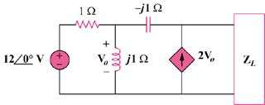

Figure 11.46
For Prob. 11.15.

